Solution Architecture

Date | 2 February 2026
Team ID | LTVIP2026TMIDS74755
Project Name | Rising Waters: A Machine Learning Approach To Flood Prediction
Maximum Marks | 2 Marks

Minimum Viable Architecture:
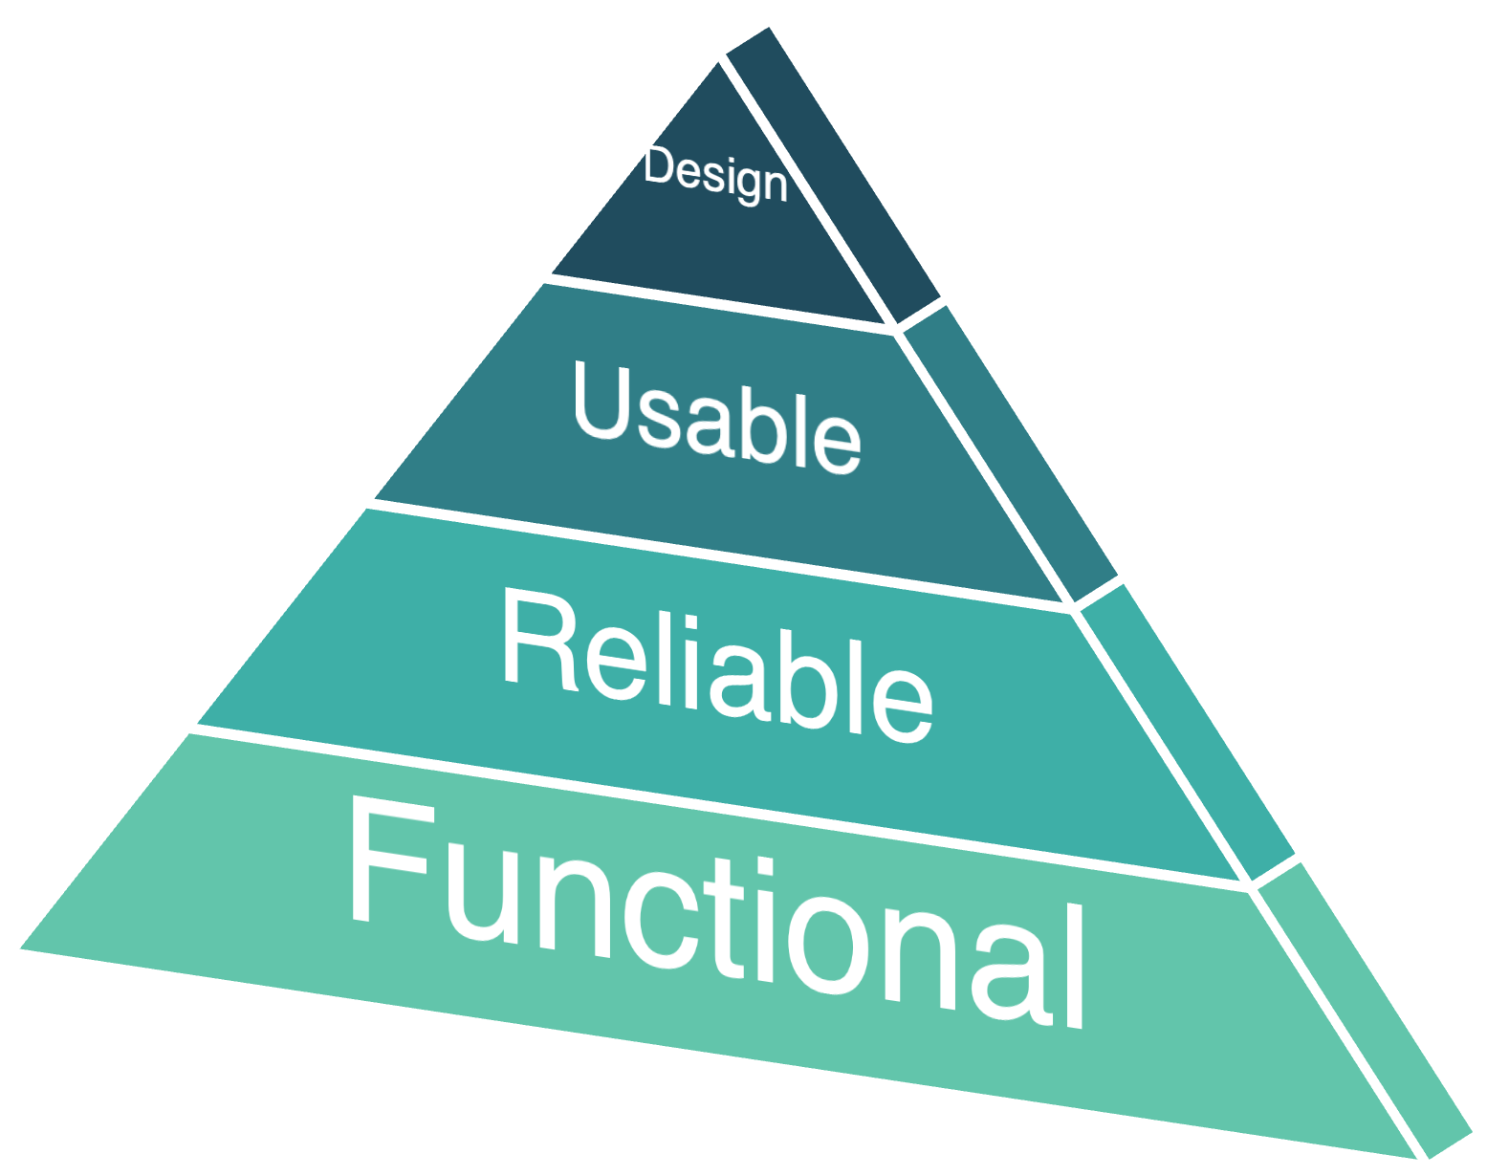
Iterative design would allows additional environmental features or modules to be added in future.
The predicted output assists disaster management teams and people in flood-prone areas.
Features such as temperature, humidity, cloud cover, and rainfall distribution are selected for datasets and scaled
Classification-based flood prediction is performed for early warning and prior decision-making.

